**Musa Haji**

**230701391**

**EX NO. 6**

**CLASS DIAGRAM**

AIM :-

To draw a sample class diagram for your project or system.

**Diagram**

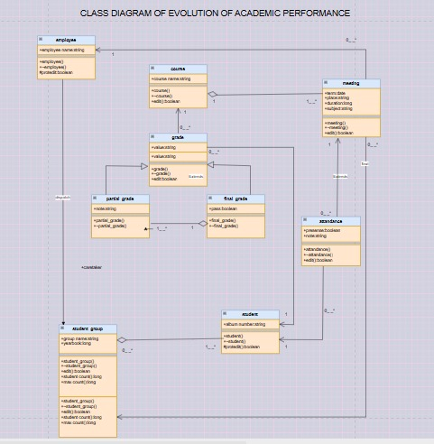

Result:

The use case diagram was designed successfully.